

**School of Information Technology**

Course : Diploma in Business Informatics

Subject : ITP282 - Enterprise Application Development & Project

AY / Sem : 2018 S2

## Lab 2a: Web Application Development with ASP.NET and C# (CPF Calculator)

### OBJECTIVES:

By the end of this Practical students should be able to:

* Create an Empty ASP.NET Website.
* Add a Master Page.
* Add controls to a Web Form.
* Understand the relationship between the properties of a control in ASP code and the Properties window.
* Change the properties of controls in:
  1. *Properties* window.
  2. ASP code in *Source* view.
* Work with events and event handlers.
* Understand how ASP.NET binds event handlers to controls.
* Understand how the Properties window displays the event handlers bound to controls.

# Introduction

Today, we will use Visual Studio to create a simple CPF Calculator Web Application.

An employee who works for a company will need to contribute to his CPF account which consists of the Ordinary, Special and Medisave Account. The company he works for will also need to contribute to his CPF account. The company's contribution is separate and is NOT taken from the employee's salary.

The contribution rates by the employee and his employer are shown in the table below.

Table 1

|  |  |  |  |  |  |
| --- | --- | --- | --- | --- | --- |
| **Employee Age (years)** | **Contribution By Employer (% of salary)** | **Contribution By Employee (% of salary)** | **Credited Into** | | |
| **Ordinary Account (Ratio of Con)** | **Special Account (Ratio of Con)** | **Medisave Account (Ratio of Con)** |
| 35 & below | 14.5 | 20 | 0.6667 | 0.1449 | 0.1884 |
| Above 35 to 45 | 14.5 | 20 | 0.6088 | 0.1739 | 0.2173 |
| Above 45 to 50 | 14.5 | 20 | 0.5509 | 0.2028 | 0.2463 |
| Above 50 to 55 | 10.5 | 18 | 0.4562 | 0.2456 | 0.2982 |
| Above 55 to 60 | 7.5 | 12.5 | 0.575 | 0 | 0.425 |
| Above 60 to 65 | 5 | 7.5 | 0.28 | 0 | 0.72 |
| Above 65 | 5 | 5 | 0.1 | 0 | 0.9 |

## 

## Allocation of CPF Contributions

The CPF contributions are allocated to the Ordinary, Special and Medisave Accounts based on the ratio of contributions shown in **Table 1**. Contributions are first allocated to the Medisave Account, followed by the Special Account. The balance is then allocated to the Ordinary Account.

## Example:

If an employee's salary is $4000 and his age is 35 and below,

### CPF Contribution

Employer contribution = 4000 * 14.5% = 580  
Employee contribution = 4000 * 20% = 800  
Total CPF contribution = 800 + 580 = 1380

### Employee's Net Salary

Employee Net Salary = 4000 – 800 = 3200

### Amounts Credited to each Account

Special Account = 0.1449 * 1380 = 199.96  
Medisave Account = 0.1884 * 1380 = 259.99  
Ordinary Account = 1380 – 199.96 – 259.99 = 920.05

**Important:** We calculate the Ordinary Account by subtracting Special Account and Medisave Account from the CPF contribution to account for errors that may be introduced by rounding up. This is a very important for financial calculations and other calculations that need to accurately account for every unit.

# Exercise 1

We will first create a prototype of the application where the contribution is calculated using the rates for age 35 and below.

## Creating the UI

1. Create a **new empty website** by:
   1. Select *File 🡺 New Web Site…*.
   2. In the *New Web Site* dialog:
      1. Under *Installed Templates*, select *Visual C#*.
      2. Select *ASP.NET* ***Empty*** *Web Site*.
      3. For the Web Location, use **Lab02a_CPF_Calculator**as the folder name.
2. Add a Master Page to the web site by:
   1. Select *Website 🡺 Add New Item…*.
   2. Select *Visual C#*.
   3. Select *Master Page*.
   4. Change the file name to *Main.master*.
   5. Tick *Place code in separate file*.
   6. Un-tick *Select master page*.

**TIP:** When you create any significant ASP.NET Web Application, it is a good idea to create a Master Page and then make sure all your ASPX web pages use the Master Page. If the Master Page is not needed eventually, you can just leave it blank. If it is needed, then you don't need to make major changes to the ASPX web pages just to add a Master Page.

1. Create a new C# Web Form named **Ex01.aspx**(the 3rd character is the number zero and NOT the letter 'O'):
   1. With code behind (hint: which box do you need to tick?), and
   2. Use *Main.master* as the master page (hint: which box do you need to tick?).
2. Add the HTML code shown in Figure 1 to **Ex01.aspx**.

Add this HTML.

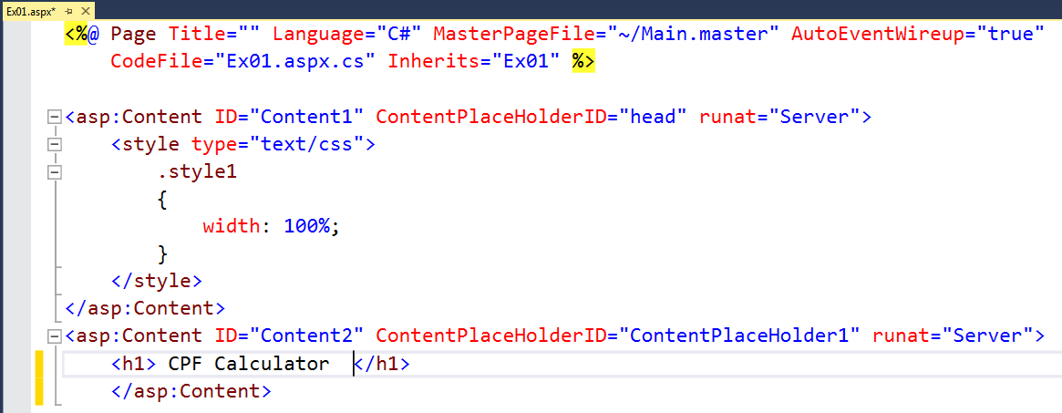

Figure 1: ASP.NET codes of Calculator Web Form

1. **TIP:** Press Ctrl + K + D on your keyboard. If there is nothing wrong with your code, VS will auto format your code neatly with proper indentation.
2. Switch to *Design* view of *Ex01.aspx* and insert a table with 3 rows and 2 columns by:
   1. Place the keyboard cursor after the words *CPF Calculator* and press the Enter key on your keyboard.
   2. From the menu bar, select *Table 🡺 Insert Table*.
   3. In the *Insert Table* dialog, set 3 rows and 2 columns.
   4. Click the *OK* button.
3. You should now have a table on your *Ex01.aspx* web form. From the *Toolbox* panel, drag a *Textbox* control into the cell at 1st row, 2nd column. (When you do that, the table might resize its columns. That is normal as we have not fixed the width of the columns.)
4. Add a Label control into the table by:
   1. Placing the keyboard cursor in the 2nd row, 2nd column.
   2. Double clicking on *Label* in the *Toolbox* panel.
5. Now you know two ways of adding controls to a web form. Continue and create the web form as shown in Figure 2.

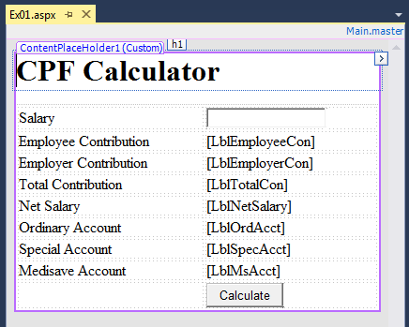

Figure 2: Design of CPF Calculator Web Form

**Important:** From your previous programming modules, you would have learned the importance of Naming Conventions, to make our programming tasks easier.To make it easier to recall the purpose of each of the controls on our web form, we should adopt a Naming Convention to set the IDs of the controls to reflect their Type and Purpose. For **ITP282**, we will use a prefix to indicate the Type of the control and a suffix to indicate the Purpose of the control.

We will use ***Tb***, ***Lbl*** and ***Btn*** to as the prefix of the *IDs* of ***Textboxes***, ***Labels*** and ***Buttons*** respectively.

So, according to our naming convention, the *Textbox* in Ex01.aspx should be named *TbSalary*, as it is a ***Textbox*** for entering the employee's **salary**.

1. Change the *ID* property of the *TextBox* by (see Figure 3):
   1. Select the *Textbox* by clicking on it in *Ex01.aspx* web form (NOT the *Textbox* in the *Toolbox* panel).
   2. Look for *(ID)* in the *Properties* window.
   3. Change the value of *(ID)* to *TbSalary*.

**TIP:** If you cannot find the *Properties* window, you can find it in the *View* menu. On the menu bar, click *View 🡺 Properties Window*. Or press F4 on your keyboard. Similarly, you can find and open the other windows and panels like the *Solution Explorer* by exploring the *View* menu.

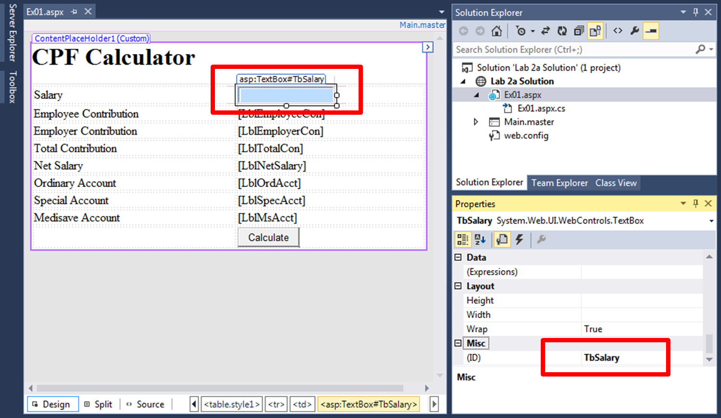

Figure 3

1. Now, let's learn a different method to change the *ID* of a control:
   1. Switch *EX01.aspx* to *Source* view.
   2. Look for *Employee Contribution* in the code.
   3. Then, look for the *Label* control associated with it. (Hint: look for <asp:Label …>.)
   4. Change the *ID* property/attribute to *LblEmployeeCon* (the first 3 letters are capital L, small B and small L.)

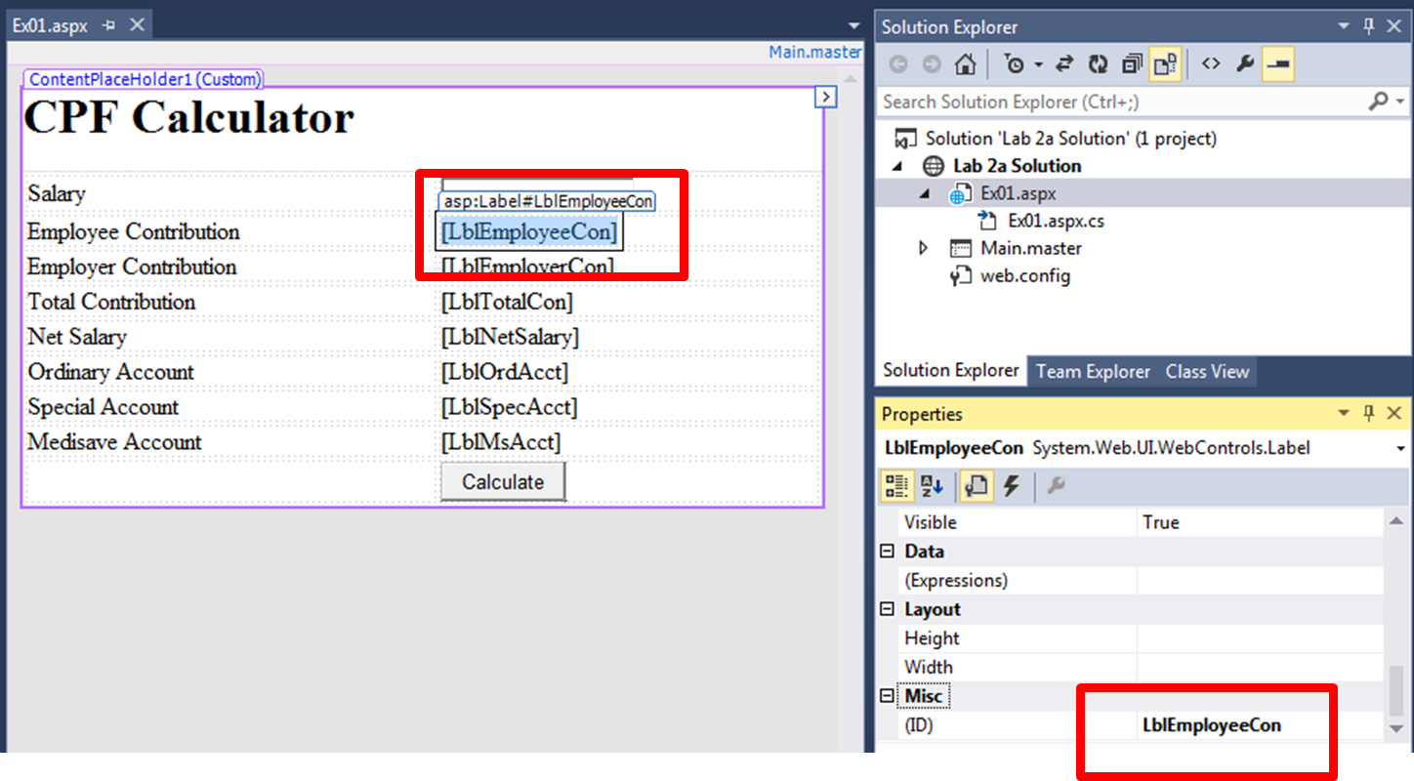

**Figure 4a : Design View and Properties (for LblEmployeeCon)**

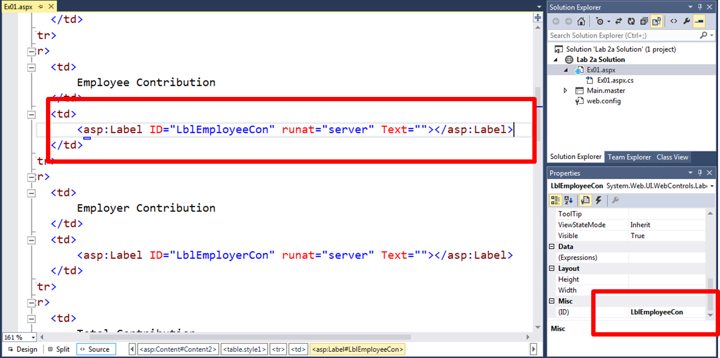

Figure 4b : Source View and Properties (for LblEmployeeCon)

1. From the above two methods of editing the IDs of the controls, what conclusion can you make about the relationship between the *Properties* window and the property/attributes of the ASP code in *Source* view?

**Answer:**

**Important:** What we call *attributes* in HTML code, are called *properties* in ASP code. From now on we will use the word ***properties*** instead of ***attributes*** for both HTML and ASP. Do remember that outside of this module and in the future, the two words may be used interchangeably by your classmates, lecturers/tutors and co-workers to refer to the same thing.

1. Now, change the *IDs* and *Text* properties of all the controls in Ex01.aspx as shown in Table 2. You may use the *Properties* window or edit the ASP code directly in *Source* view.

Table 2: UI Controls for CPF Calculator Web Form

|  |  |  |  |
| --- | --- | --- | --- |
| **Control** | **ID Property** | **Text Property** | **Remarks** |
| Employer Contribution Label | LblEmployerCon |  | Delete the current value of all the *Labels* (which is Label) and leave it empty. |
| Total Contribution Label | LblTotalCon |  |
| Net Salary Label | LblSalary |  |
| Ordinary Account Label | LblOrdAcct |  |
| Special Account Label | LblSpecAcct |  |
| Medisave Account Label | LblMsAcct |  |
| Button | BtnCalculate | Calculate |  |

## Implementing the Logic

We want the Web Application to calculate the CPF contribution and the distribution to the 3 different accounts accordingly when the user types in his/her salary and clicks the *Calculate* button. To do that, we need to bind (or link) the click event on the *Calculate* button to an *Event Handler*.

An *Event Handler* is simply a C# method that is automatically called when the respective bound event happens. Most of the ASP.NET controls have more than one possible event, but they usually have a *Default Event Handler* for their frequently triggered event. For example, the *Default Event Handler* of the *Button* control is for the *Click* event. VS will automatically create the *Default Event Handler* for us when we double-click on a control.

Another *Default Event Handler* that we have encountered in the previous labs is the *Page_Load* event for our Web Forms.

There are other methods of adding event handlers. We will explore those methods in a later lab. For now, we shall just create the event handler for the *Calculate* button and add the necessary C# code to perform the calculations.

## Creating and Binding an Event Handler

1. Open *Ex01.aspx.cs* and examine it. Notice there is only **ONE** method in the class, the *Page_Load* event handler (see Figure 5).

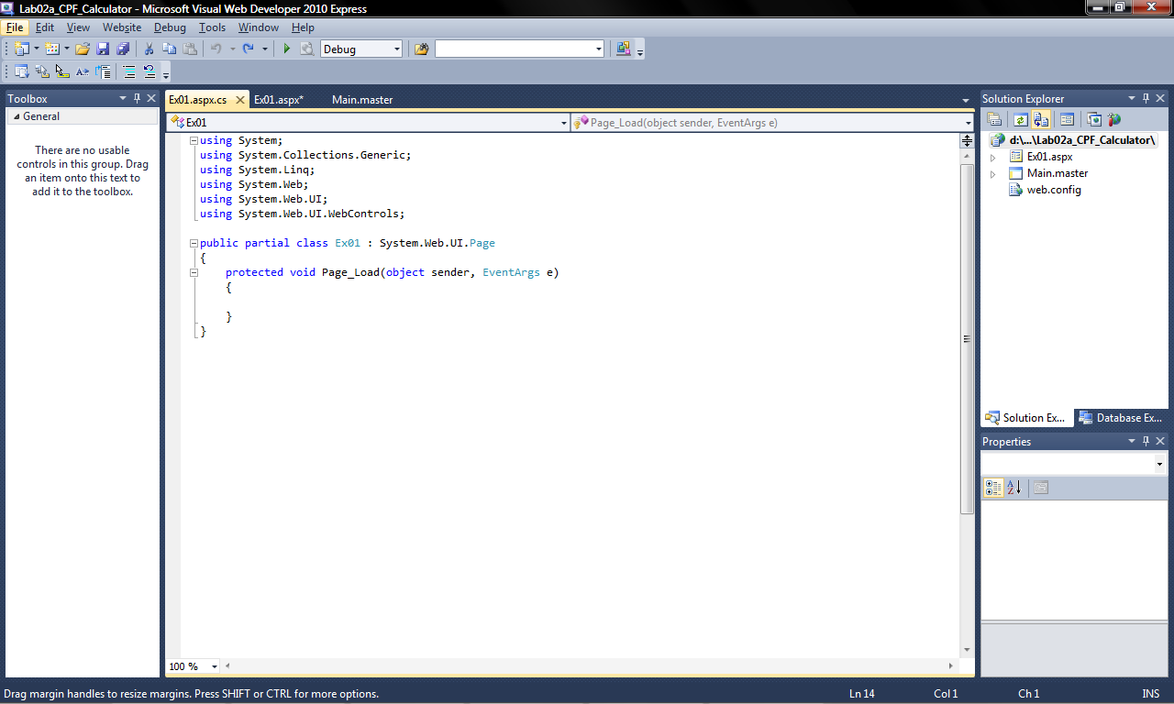

Figure 5: Code Behind of Web Form

1. Switch to the *Design* view of *Ex01.aspx* and double-click the *Calculate* button. VS will automatically switch to *Ex01.aspx.cs* file and add the click event handler for you (see Figure 6). Notice also, that its name uses the ID of the *Calculate* button (*BtnCalculate*) and the event (*Click*).

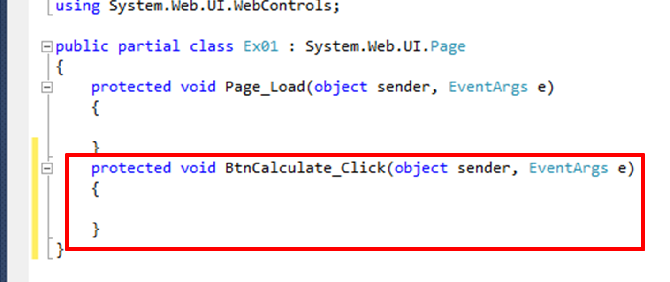

Figure 6

1. Go back to the *Design* view of *Ex01.aspx*.
2. Select the *Calculate* button.
3. In the *Properties* window, click on the *Lightning Bolt* icon (see Figure 7).
4. Look for the *Click* action (see Figure 7). Examine its value and notice it is the name of the click event handler that was just created in *Ex01.aspx.cs*.

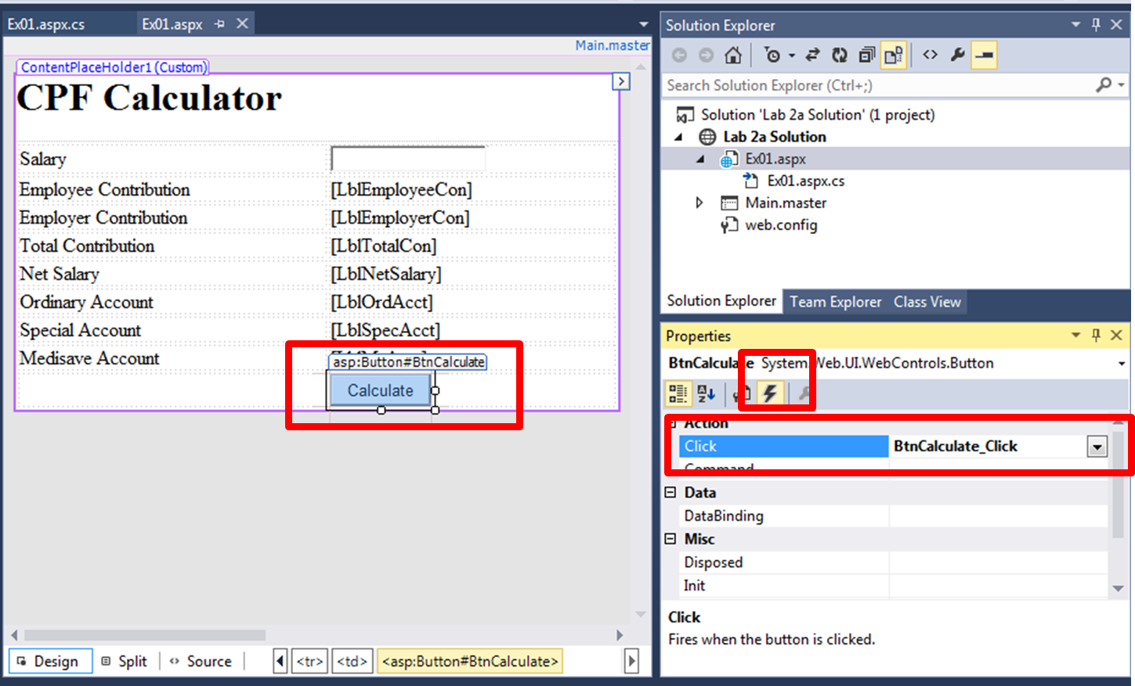

Figure 7

1. Switch to the *Source* view of *Ex01.aspx* and look for the *Calculate* button's ASP code (see Figure 8). Notice that VS has also added an *onclick* property to it, and the value is the name of the click event handler that was just created in *Ex01.aspx.cs*.

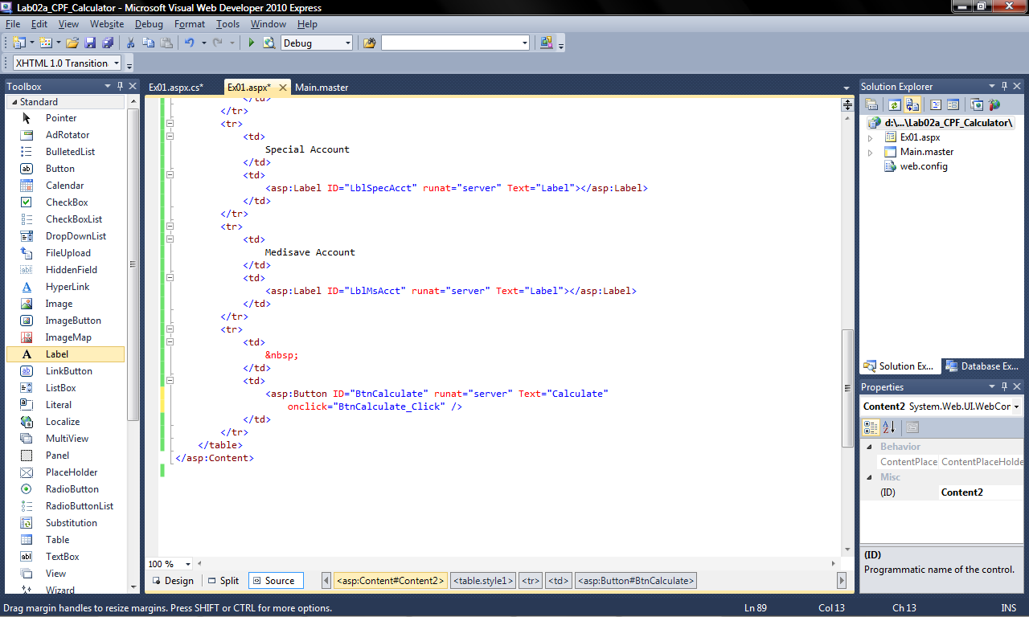

Figure 8

1. Can you see how ASP.NET binds the event handlers to the ASP.NET controls? And how that is represented in the *Properties* window?

## Programming the Logic

In this step, we shall write the C# code to calculate the various values.

1. Switch to *Ex01.aspx*.
2. Add the C# code shown in Figure 9 to the *BtnCalculate_Click* event handler. Be sure to copy and read the comments as they explain some of the code.

Figure 9

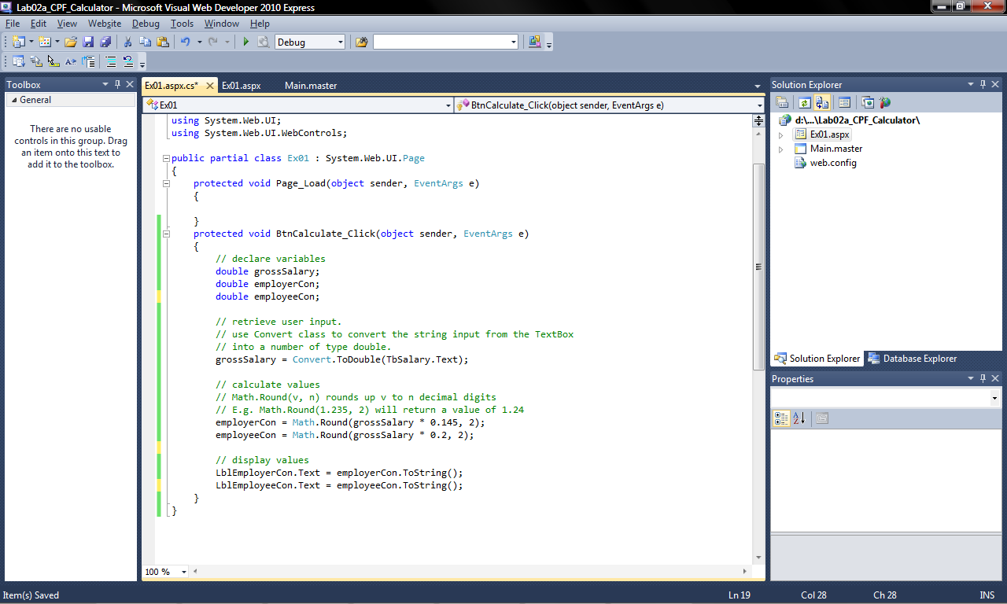

## Testing the Web Application

1. Test the web application (recall how we did that in the previous labs).
2. Enter 4000 in the *Textbox* and click the *Calculate* button. Your results should match Figure 9 (don't worry if the layout does not match exactly).

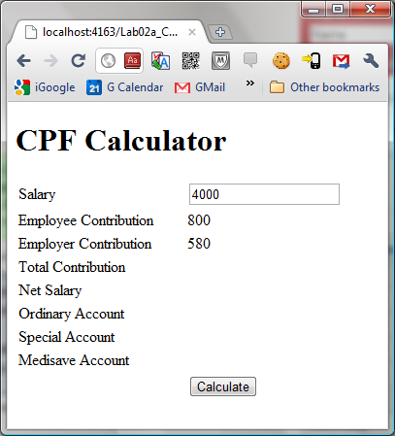

Figure 10

## Complete the Logic and Test

1. Write the rest of the code on your own to complete all the calculations assuming that the user is 35 years old or younger. We have not yet learnt how to validate the user's input, so do not worry about that yet, and expect the Web Application to display an error if you enter non-numeric values.
2. As you write the code, test your web application to check your work.
3. Once you have completed, do a final test to make sure everything is working correctly. The final results for 4000 should be as shown in Figure 11.
4. Show your completed work to your tutor.

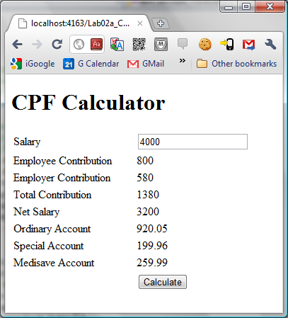

Figure 11

## Conclusion

In this practical, you have learnt:

* How to create an Empty Website.
* How to add a Master Page.
* How to add controls to a Web Form.
* How to change the properties of controls in:
  1. *Properties* window.
  2. ASP code in *Source* view.
* Work with events and event handlers.
* How ASP.NET binds event handlers to controls.
* How the Properties window displays the event handlers bound to controls.

**========== End ==========**